Name: _____________________ Period: ____ Date: __________

Interactive Number Line Activity - Part 1

In part 1 of this activity you will use an interactive number line to model the addition and subtraction of integers.

Please go to http://www.pky.ufl.edu/~technology/numberline.html and then answer the following questions. Begin by experimenting with the applet to see how it works. You can click and drag the two points on the number line and see how they change the addition/subtraction problems.

Adding & Subtracting Integers:

In the "Sample Problems" section of the applet answer 6 problems correctly. Use the number line to help model the problems. Record the six problems and their answers in the area below.

1) | 2) | 3)
4) | 5) | 6)

Writing Equations:

Write the addition problem (including the solution) that is shown in each graph.

7) | 8)
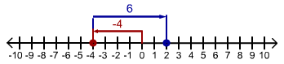
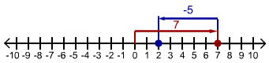

Write the subtraction problem (including the solution) that is shown in each graph.

9) | 10)

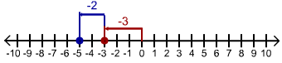
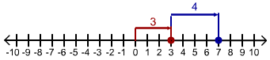

Name: _____________________ Period: ____ Date: __________

Interactive Number Line Activity - Part 2

In part 2 of this activity you will use the number line to explore the rules for adding and subtracting integers. Use the interactive number line to answer each of the following questions (http://www.pky.ufl.edu/~technology/numberline.html).

Two Positive Numbers:
- Slide the red and green points up and down the number line. When the first and second number in the problem (the red and blue numbers on top) are both positive, is it possible to get a negative answer?

Two Negative Numbers:
- Slide the red and green points up and down the number line. When the first and second number in the problem (the red and blue numbers on top) are both negative, is it possible to get a positive answer?

One Positive and one Negative Number:
- Set the red point at 5 on the number line. Slide the green point up and down the number line.

- When the value of the second number (the blue number on top) is less than _____ , then the answer is negative.

- When the value of the second number (the blue number on top) is greater than _____ , then the answer is positive.

Set the red point at -5 on the number line. Slide the green point up and down the number line.

- When the value of the second number (the blue number on top) is less than _____ , then the answer is negative.

- When the value of the second number (the blue number on top) is greater than _____ , then the answer is positive.

The Problem:
- When the addition problem is adding a positive number, the subtraction problem is

subtracting a ______________ number.

- When the addition problem is adding a negative number, the subtraction problem is

subtracting a ______________ number.

