Name: ______________________________ Period: _____ Date: ______________

Bus Grapher Game Activity

This activity uses an applet found at: http://plaza.ufl.edu/youngdj/applets/busgrapher.html . Please read the instructions for the game and then begin with the easy levels.

Easy Levels:

Complete the easy levels and then answer the following questions.

- Identify the dependant and independent variables represented on the graph.

Dependant Variable: _________________ Independent Variable: __________________

- Describe the movement of the bus when the graph is flat.

- Describe in words the movement of the bus shown in the graph below:
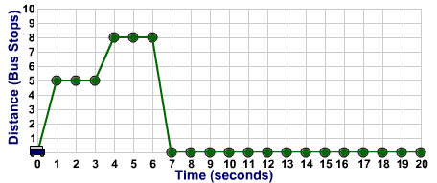

- What is the largest number people you can possibly pick up and return to the station in one turn?

Medium Levels:

Complete the medium levels and then answer the following questions.

- How does the slope or steepness of the line affect the movement of the car?

- A slope of 3 means the bus travels past ___ bus stops in ____ second.

- If the speed limit is 9 can the bus drive directly from the station to bus stop 10?

For 8 – 11 use the graph below to answer each question:

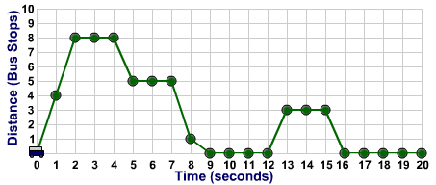

- What is the speed of the bus between 0 and 2 seconds?

- What is the speed of the bus between 5 and 7 seconds?

- During which interval of time is the bus moving most slowly?

- What is the lowest speed limit that this level could have for the bus not be pulled over?

Hard levels:

Complete as many of the hard levels that you have time for and then answer the following questions:

- Which level were you able to get up to?

- What made these levels more difficult than the previous levels?

Level Editor:

Find a partner for this part of the activity. Create a level for your partner to try.

- Write the objective for your level below:

- Draw the people and speed limit you chose for your level onto the blank scenario below. Then draw a graph that would be a solution to your level:
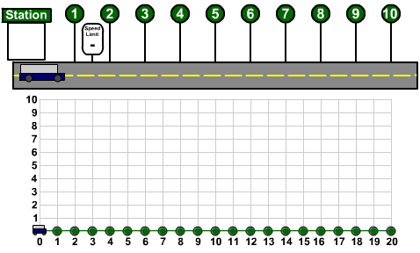

- Would you categorize your level as easy, medium, or hard? Why?

- Have your partner try to solve your level. Then have your partner rate your level as easy, medium or hard, and explain why he/she chose that category for your level.

