Bus Grapher
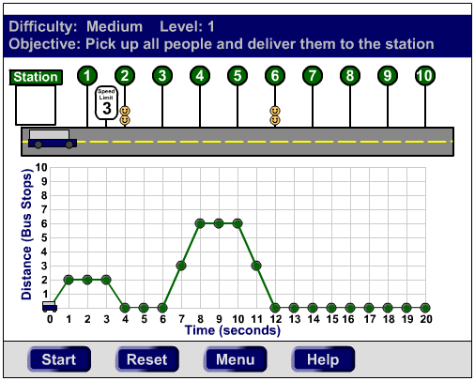 | URL: http://plaza.ufl.edu/youngdj/applets/busgrapher.html  Description & Goals: Bus Grapher was developed as a culminating project for a Game Theory and Design class. The goal in developing this applet was to provide an instructional experience in a game environment without using drill-and-skill techniques. The object of the game is to pick up people and return them to the station without exceeding the speed limit. To accomplish this task, students must define the movement of the bus by constructing a distance vs. time graph.
Concepts & Skills: The table below describes the specific concepts and skills addressed in this applet and shows how the gaming structure advances learning through the stages of Bloom’s Taxonomy.

Levels of Bloom’s Taxonomy | Bus Grapher Levels | Concepts & Skills Addressed
Knowledge & Comprehension | Easy | To complete the easy levels students must have a basic knowledge of graphing skills including creating and reading line graphs and defining dependant and independent variables. Additionally, they must comprehend how the position of the bus on the road relates to the shape of the graph and make predictions about how changes in their graphs will relate to movement of the bus.
Application & Analysis | Medium and Hard | To complete the medium levels students must compute the slope of their graphs and construct them according to the constraints of the speed limit. The hard levels add a problem solving element in which students must distinguish which people must be picked up or left behind, all while applying the previously addressed skills and concepts.
Synthesis & Evaluation | Level Editor | In the level editor students have the opportunity to synthesize all the concepts and skills addressed in the game by creating levels to challenge other students. To create challenging levels students must demonstrate an ability to distinguish the features of previous levels that make them challenging as well as a thorough understanding of all the concepts and skills addressed by completing the previous levels and the constraints created by the rules of the game.

Activity / Lesson: In order to ensure learning, especially at the higher levels, it is recommended that this applet be used in conjunction with a classroom lesson plan that prompts the students to use it appropriately and recognize the key concepts and skills it addresses. The sample activity for this lesson can be viewed at http://plaza.ufl.edu/youngdj/applets/bus_grapher_activity.doc . This activity was used in a classroom in which each student worked at their own computer. It is suggested that the students complete each section individually as the teacher circulates to provide assistance, and that the class engage in teacher-led discussion at the end of each section.

Assessment: The applet itself provides formative assessment by prompting students to complete the level objectives and keeping track of which level difficulties have been completed. Summative assessment is included in the accompanying activity in which skill and thought questions measure the students’ understanding of the concepts shown in the applet. Additionally, it is expected that the teacher will monitor student progress and provide guidance throughout the activity.

