Equation Balance: 1-Step Addition and Subtraction
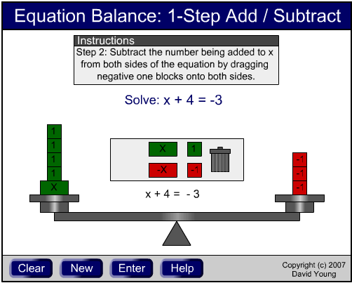 | URL: http://plaza.ufl.edu/youngdj/applets/eq_addsub.html  Description and Goals: The equation balance applet provides a model to understand how equations are solved by representing them on a balance. A primary goal for developing this applet was that the equations would be not only set up, but also solved by manipulating the blocks on the balance. It was important to provide a connection between the concrete balance model and the traditional method of solving equations by hand.
This applet features several design elements that enhance its effectiveness. Randomly generated problems provide extensive practice and students are also able to enter their own problems to solve. The “Help” section provides assistance with using the applet as well as solving equations. The applet is limited to equations with relatively small numbers so that they will physically fit within the applet. In this case the focus is more on teaching the larger concepts behind equations so using smaller numbers is reasonable and students can extrapolate to solve similar equations with larger numbers by hand.

Concepts & Skills: The primary concept addressed in this applet is the addition and subtraction property of equality. This property is seen clearly by the fact that maintaining balance requires the same amount being added or subtracted to both sides of the equation. The specific skill addressed is solving equations, which is supported by the inclusion of the traditional symbolic method being shown clearly in the center of the applet as the equation is set up and solved. A secondary concept that is addressed is the understanding of addition and subtraction of integers, which is often a stumbling block for students working with these equations. This concept is reinforced concretely by using the blocks as Algebra tiles in which students must cancel objects by dragging opposite pairs on top of each other.

Activity / Lesson: The materials accompanying this applet include an introductory video as well as a study guide. The goal with this combination is that a student in an online course, or a student working independently, could watch the video and complete the activity on their own. The introductory video is an appropriate model for how a teacher could present the concepts shown in this applet to a class. The study guide provides practice solving equations on the applet as well as extrapolating to solve equations with numbers too large to fit on the applet. It also provides thought questions that prompt deeper thinking and consideration of the underlying concept of the addition and subtraction property of equality.

Assessment: The applet provides formative assessment by prompting students with the steps to solve equations and indicating when each step is complete. It also provides randomly generated problems (restricted to numbers that fit on the scales) for extensive self-assessment. Summative assessment is provided through the study guide.

