Name: _______________________

Section 4: Quiz

Please answer each part of every question and show all your work. (26 points possible)

Describe the slope of each line below as positive, negative, zero, or undefined. (1 point each)

a
b
c
d

1. Line a

2. Line b

3. Line c

4. Line d

Find the slope of the lines shown in 5-6. Please show your work. (2 points each)

5. Slope = | 6. Slope =

For 7 - 8 Find the slope of the line that passes through the two given points. Please show work. (2 points each)

7. (2, -4) and (-3, 6) | 8. (4, 7) and (4, -3)

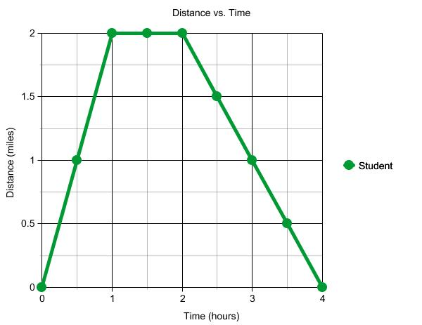
The graph below represents a students distance away from home over a period of 4 hours. Use the graph to answer the questions below. (2 points each, one for your answer, one for the explanation).

9) What can you conclude about the student's actions from 1 to 2 hours? How do you know?

10) Did the student travel faster as he moved away from home or back towards home? How do you know?

11) What was the speed of the student (including units) from 0 to 1 hours?

The graph below shows data from two race cars for a 10 mile race. Use the graph to answer the questions below. (2 points each, one for your answer, one for the explanation).
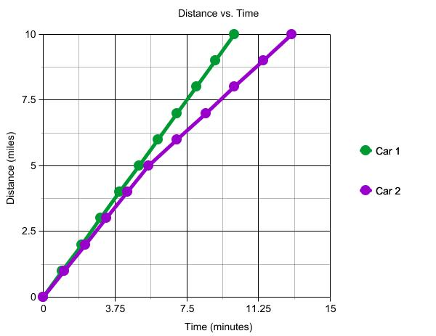
12) Who won the race? How do you know?

13) Did the cars drive the same speed for the whole race? How do you know?

14) What would be a good estimate of car 1's average speed throughout the race? Why is this a good value?

15) What would be a good estimate of car 2's average speed throughout the race? Why is this a good value?

