By: David Young, youngdj@ufl.edu

Interactive Excel Worksheets Tutorial

Part 1: Using Scroll Bars

This is the first in a 2-part tutorial on making interactive worksheets in excel. These tutorials assume that the user is familiar with basic operations in excel including navigating in excel, cell formatting and layout, functions, and graphing. You can view the sample excel file that accompanies this tutorial here: http://plaza.ufl.edu/youngdj/tutorials/excel_interactivegrphing.xls

- Open Microsoft Excel and save your file. Remember to save your progress after each step of the tutorial.

- Ensure that the "Control Toolbox" Toolbar is visible. To do this go the "View"→"Toolbars" and select "Control Toolbox" if it is not already checked. The "Control Toolbox" toolbar should now be visible at the top of your page, it looks like this:

- Insert a scroll bar into your spreadsheet. Click on the insert scroll bar button on the "Control Toolbox" toolbar: . Click on the spreadsheet and drag the mouse to draw a scroll bar onto your sheet.
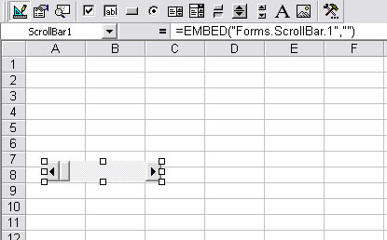

- Note: After drawing your scroll bar onto your sheet, you can click it to select it and drag the corners of it to resize it. You can also drag it to different points on the sheet.

- Next we will set the properties of the scrollbar. Select the scroll bar by clicking on it. To view the scrollbar properties you can either click the "Properties" button on the "Control Toolbox" toolbar, or you can right click the scroll bar and select "Properties. The "Properties" window for the scrollbar will open. Click on the "Categorized" tab at the top of the window to view the scrollbar properties by category.

Change the properties of the scrollbar as follows:  - Appearance: You can change the colors of the background and foreground as desired. This is optional, but try playing with the colors and making the background dark blue and the foreground white.  - Misc:  - Set the "(Name)" to "Slope" as we will be using this scrollbar to control the slope of the line.  - Set the "Linked Cell" to "A2"  - Scrolling:  - Set "Min" to zero  - Set "Max" to 40  - Set "Small Change" to 1  - Set "Large Change" to 2  Close the "Properties" window when you are finished making changes.  Note: With these settings, the scrollbar will change the value of cell A2 on the spread sheet. The value of the cell will range from 0 to 40 and will scroll in small increments of 1 and large increments of 2. | 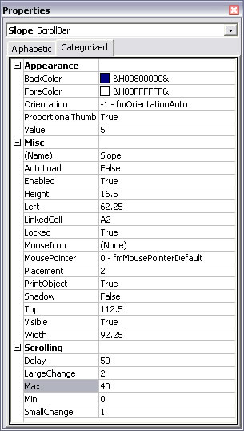

- Now we will test the scroll bar. The "Design Mode" button on the "Control Toolbox" toolbar looks like this: . Notice that when you inserted the scrollbar, the "Design Mode" is activated, and this button is indented. In "Design Mode" when you click on a control, like a scroll bar, you are able to change the appearance of the control and it's position on the page. Now click the "Design Mode" button to exit design mode and click on your scroll bar. The scrollbar should now behave like a regular scroll bar. Notice the values in cell A2. They should range from 0-40 as you adjust the scroll bar.

- Setup the layout of your worksheet. You can see my layout in the picture below. To achieve this, I changed the font on the area I am working to 12 point, bold. I used the bold outline to outline cells C4 and F4, which are left blank for now. I also added a bold outline in the cells surrounding the "slope" scroll bar and made a space to add a scrollbar for the y-intercept, which we will do in the next step. I added the title to cell A1 and made it a bold 20 point font. I also centered the text in cells C4-F4. Remember to go into "Design Mode" to move and adjust the size of the scrollbar.

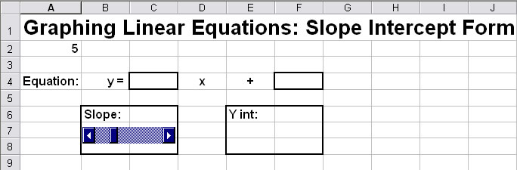

- At this point you may be wondering why we linked the slope scroll bar to cell A2 and not C4. The reason is that the scrollbar does not handle negative numbers or decimal values. Adjusting slope from 0-40 is not practical, so we will use a function to convert the value in cell A2 to the value we want for the slope. Click on cell C4, then click on the equals symbol ("Edit Formula" pr "=") and enter the following function for cell C4: =(A2-20)/2. Now test your scrollbar. The values in cell A2 should still range from 0-40, but the values for the slope now range from -10 to 10 in increments of 0.5. In cell C6, add the function: =(C4), if you would like to have the slope in the box with the slide bar as well.

Note: Feel free to experiment with different ranges and increments for the slope. You can do this by adjusting the maximum value in the scroll bar properties, and by adjusting the equation in cell C4.

- To complete this portion of the tutorial we will now add the scrollbar for the y-intercept. In "Design Mode" select the slope scrollbar, copy it, and past it. Drag the new scroll bar to the y-int box on the spreadsheet. Change the following properties of the scrollbar (see step 4 above): (1) change the back color to dark green, change the name to "yint", change the linked cell to A3, change the "Max" to 20. Everything else can stay the same. Close the properties window and exit design mode and test your new scrollbar. Cell A3 should now be adjusting between 0-40.

- Now we will add the y-intercept value to the equation. Add the following function to cell F4: =A3-10. This will give us a range of y-intercepts from -10 to 10 at increments of 1 (Again, feel free to adjust these values to your preference). Also, you can add the function =F4 to cell F6.

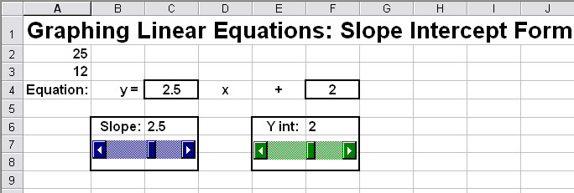
- Test your spreadsheet. It should look like the picture below. To view a sample of the spreadsheet at this point open the tutorial sample excel file and click on the "part 1" tab at the bottom.

Congratulations, you have completed part 1 of the tutorial! You are now ready to move on to part 2, where we will add a dynamic graph and table of values to the worksheet.

