David Young, youngdj@ufl.edu

Functions, Graphing and Basic Formatting in Excel

This tutorial is meant as an introduction to excel for those who have little to no experience with the program. Be sure to also view the sample excel file created in the tutorial and the video version of the tutorial.

Part 1: Functions in Excel

1. Open a new Excel spreadsheet and Click your mouse on the top left cell in the spreadsheet. Note that cells are named with Columns (letters) and Rows (numbers). This is cell A1. The name of the cell you have selected will always be visible just above the spreadsheet. | 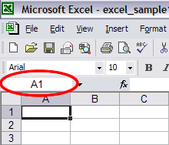
2. With cell A1 selected type the following text, “Graph of Quadratic Function”. Now click the buttons on the toolbar to make the text bold, underlined, and use the dropdown to choose size 20 font. Notice that the contents of the selected cell always appear just above the spreadsheet next to the “fx” label (even if you aren’t using a function). | 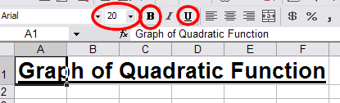
3. Now enter “x” into cell A4 and “y” into cell B4. In cell A5 enter 0. | 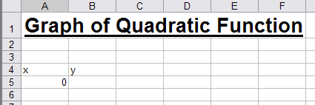
4. You could enter all the x-values manually, but instead we will use a function. Click on cell B6 and then click inside the cell value box (just to the right of the “fx”. Type “=”, then click on cell A5, then type “+1” and press enter. A6 will now equal 1. The = sign tells excel you are entering a function. Clicking on another cell refers to the value of that cell in the function, and then you add 1 to that value. Tip: Be sure to press enter before clicking on any other cells. | 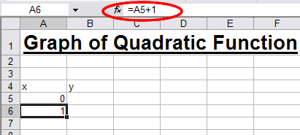
5. Now, instead of retyping the function for all values of x, we will extend the function to the cells below B6. Click on cell B6. You will notice a small square in the lower right hand corner of the bold rectangle highlighting the cell. Click on this square and drag it down until it covers cell A15. When you let go of the mouse button all the cells will have been filled according to the same function (1 number added onto the cell above it). |  | 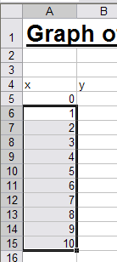
6. Now we will fill in the y-values. Click on cell B5. Click on the cell value box (just to the right of the “fx”). Type “=”, then click on cell A5 (0), type “^2”, and press enter. Cell B5 will now equal zero. This equation tells cell B6 to be equal to the square of he value of the cell just to its left. |  | 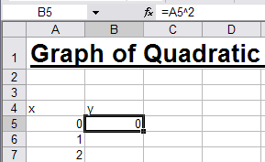
7. Use the same method as in step 5 to expand the function in cell B5 down to fill in the rest of the y-values for our table. |  | 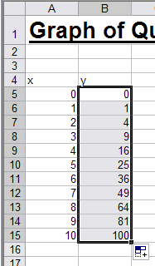
8. When you look at your table in excel you see gray gridlines, but if you print it they won’t be visible. To add gridlines first select the cells in your table by clicking on cell A4 and dragging down to cell B15, so that the whole table is highlighted. Now click on the down arrow on the “outside border” button . Then select the “all borders” button . This does a simple border around all cells in your table. |  | 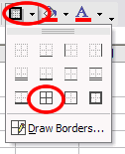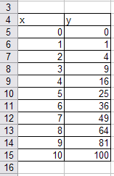

Part 2: Making a Graph

1. To make a graph of your data you must first select the data that you wish to graph. To do this select cell A5 and drag to select all of the x and y values (don’t select the title cells “x” and y”). With your table of values selected click on the “Chart Wizard” button , or go to the “Insert” menu and choose “Chart”.

2. In the Chart Wizard window that pop ups select “XY Scatter” as your chart type, and “Scatter with Data Points Connected By Lines” as your Chart Sub-Type. Then click “Next” | 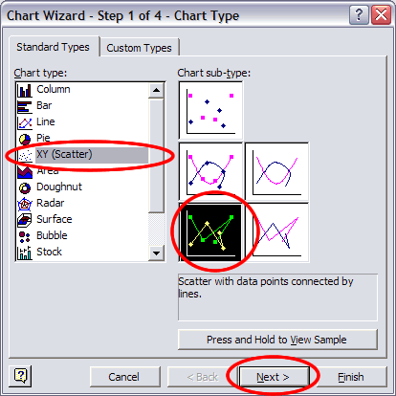
3. You do not need to change anything on Step 2 of the Chart Wizard because you have already selected your data, so just click “Next” | 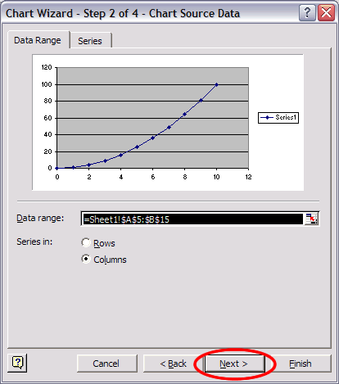
4. Chart Wizard step 3 has several options. Start by selecting the “Titles” tab and we will work from left to right through the tabs. On the “Titles” tab enter “Parabola” as the Chart title. Enter “X Values” as the Value (X) axis, and “Y Values” as the Value (Y) axis. | 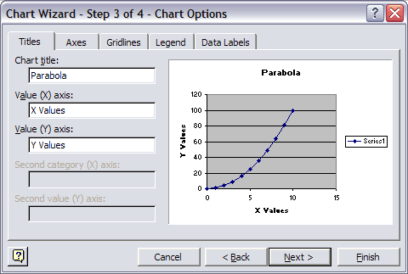
5. Select the “Axes” tab. Here you can decide if the axes labels will be visible or not. In this case you can just leave them checked. | 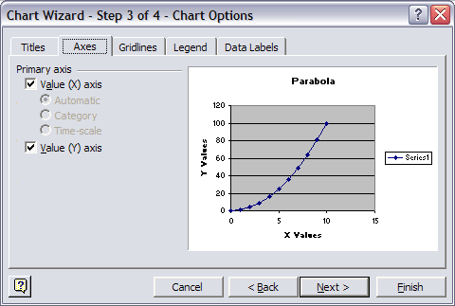
6. Select the “Gridlines” tab. Here you can choose which gridlines will be visible on the graph. In this case I will choose just Major gridlines for both the X and Y axes. | 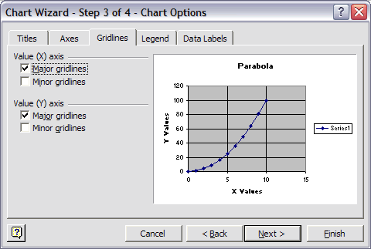
7. On the “Legend” tab you can choose to show or hide the legend. I generally prefer to hide it, so I will uncheck it. | 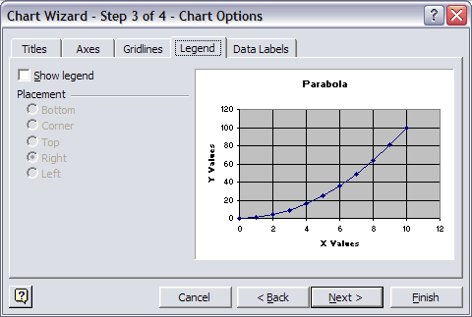
8. On the “Data Labels” tab you can decide if you want labels on each individual data point or not. I generally don’t like to use these, but you should check and uncheck them to see what they look like. | 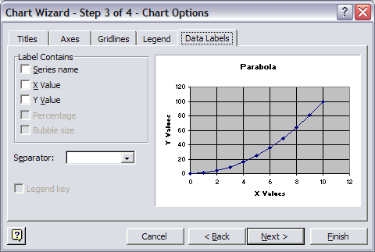
9. You don’t need to change anything on step 4 of the Wizard, so just click on “Finish”. Your new chart will show up on your spreadsheet. You can drag it wherever you want on the screen and resize it by dragging the handles on its sides and corners.
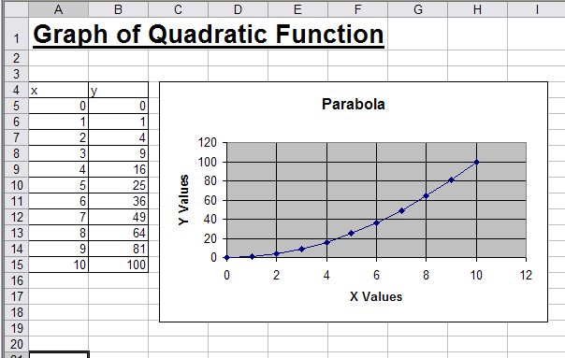
Part 3: More Functions in Excel

Now that you know how to do some basic editing and graphing in excel, we will look at how to use the built in functions in excel for some calculations. We will also look at how to use multiple sheets.

1. At the bottom of your spreadsheet you will see 3 tabs that read “Sheet 1”, Sheet 2”, and “Sheet 3”. If you click on sheet 2 or 3 you will find blank spreadsheets. If you click back to sheet 1 you will find your quadratic function graph. Right click on the “Sheet 1” tab and choose “rename”. Name the tab “Functions & Graphing”. Now rename tab 2 to be “Average”. Right click on sheet 3 and choose delete. Note that you can always add a new sheet by going to the “Insert” menu and choosing “Worksheet”.
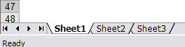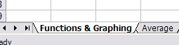

2. Go to the “Average” worksheet and enter the following values into a column in the spreadsheet. 11, 6, 12, 18, 23, 9. | 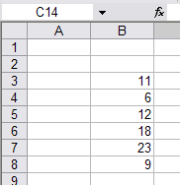
3. Now highlight the 6 values, and click on the “Sort Ascending” button to sort them from least to greatest.
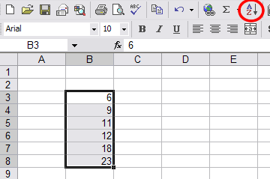

4. Now select all 6 values again and click on the “Auto Sum” button. You will see that the sum of the values now appears in the cell directly below the values. (This also works to sum values across a row, the sum will appear just to the right of the cells).
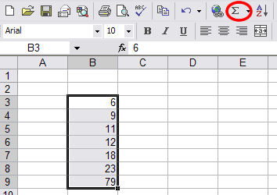

5. Click in the cell just below the sum (79). Now click in the cell value area (just to the right of the “fx”). Type “=”, the click on the 79, then type “/6” and press enter. Now you will have the average of the values in the cell. You may want to add some labels to your cells at this point. | 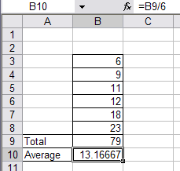
6. This is actually the long way to find the average. Now, we will look at the quick way. Click on an empty cell to the side of your values. Then click on the “fx” button next to the cell value area. In the “Insert Function” popup window choose “Average” and click “OK” | 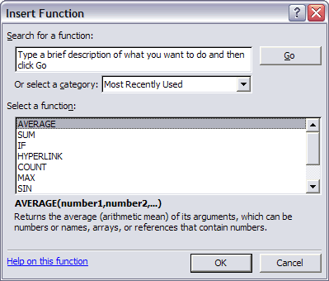
7. In the “Function Arguments” window you must choose the values that you want to average. One option is to type “B3:B8” in the “Number 1” box to average the cells from B3 to B9. Another option is to click the button next to the “Number 1” box. Then click and drag to select your values and then click the button to go back to the “Function Arguments” window. Click “OK” to finish, the average should be in the cell. | 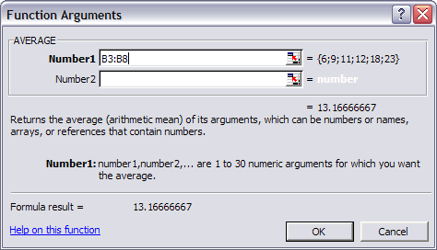
8. You now know 2 ways to find the average. Be sure to spend some more time playing the other functions that are built into excel. Notice that on the “Insert Function” window you can use the “Select Category” dropdown menu to find different types of functions.

