David Young, youngdj@ufl.edu

Creating Single Use Spreadsheets in Excel (Functions, Graphing, and Advanced Formatting)

In this tutorial you will learn how to create a single-use spreadsheet in Excel. A single-use spreadsheet is a spreadsheet that is created for a single purpose. Usually, the user is able to input values which have an effect on pre-set functions that change values. In this case we will create a spreadsheet in which the user enters values for slope and y-intercept, and a table of values and graph are automatically created. Additionally, we will use conditional formatting to insert questions with feedback into the spreadsheet.

Note that this tutorial assumes that the user is familiar with basic function, graphing, and formatting techniques in Excel. Be sure to also view the sample excel spreadsheet and video tutorial that accompany this tutorial.

Part 1: Setting Up the Functions and Graph

- Start with a spreadsheet that looks roughly like the one shown below. To see more detail look at the “Starting” sheet in the sample excel file.
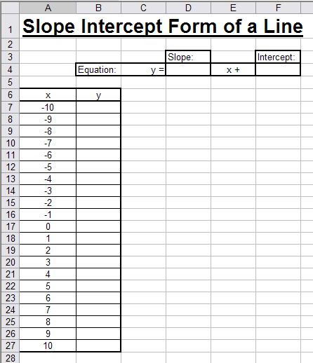

- Now we will fill in the y values. Click on the first empty Y-value cell (B7) in my example. Now click in the cell value area just above the sheet and next to the “fx”. Type “=”, then click on the empty cell under the slope label (D4), type “*”, click on the -10 cell (A7), type “+”, click on the empty cell inter the intercept label (F4), and click enter. When you click on this cell now (B7) the cell value will read: “=D4*A8+F4”. | 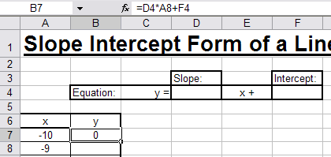
- Before applying this function to other cells we need to make a few adjustments. Select cell B7 again and click on your function to edit it. Change it to read, “=$D$4*A8+$F$4”.

Notice that the difference is that you are placing the $ in front of each letter of the cell name for the slope and y-intercept values. The $ signs mean that the reference to the cell is absolute, so if you copy the equation to another cell it will still refer to D4 and F4. However, it will refer to whatever cell is directly to the left of a selected cell for A8.

- Now we will apply the function to the rest of the y-vales. Select cell B7. You will notice a small square in the lower right hand corner of the bold rectangle highlighting the cell. Click on this square and drag it down until it covers all of the y-values. When you release the mouse button you will notice that all value have been filled in.  Currently all y-values are equal to zero because the slope and intercept cells are empty. Enter 1 into both cells and you will see that the y-values no have numbers. | 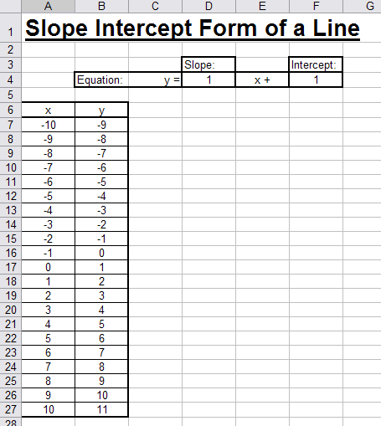
- Next we will create the graph of the function. To do this select all of the values in the table (not the title x and y cells) and click on the “Chart Wizard” button , or go to the “Insert” menu and choose “Chart”.

- In the Chart Wizard window that pop up select “XY Scatter” as your chart type, and “Scatter with Data Points Connected By Lines” as your Chart Sub-Type. Then click “Next” | 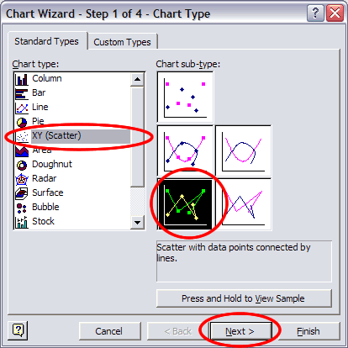
- You do not need to change anything on Step 2 of the Chart Wizard because you have already selected your data, so just click “Next”

- Chart Wizard step 3 has several options. In the “Titles” tab I am choosing to leave all titles blank in this case (you can add them if you want). On the “Axes” tab select the “Value X Axis” and “Value Y Axis” options. On the “Gridlines” tab select major and unselect minor gridlines for both X and Y. On the “Legend” and “Data Labels” tab deselect everything. Click on “Finish” and your graph will show up on your sheet. 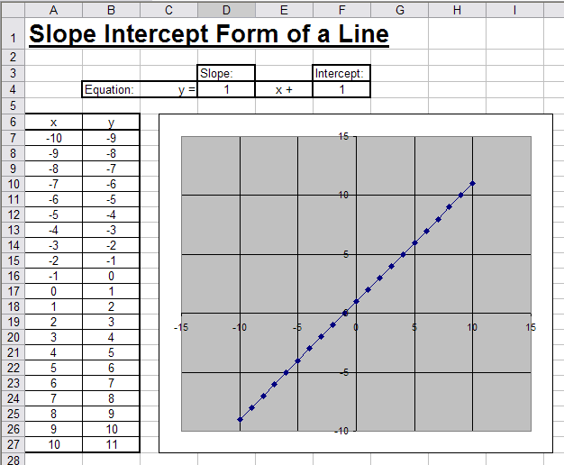
Note that you will have to drag and resize your graph if you want it to be shaped and positioned the same as it is in the picture above.

- The next thing we will do is to set the scale of the graph. Otherwise, when we change values the graph will automatically change scales, which can be distracting. To do this right-click on any of the x-axis gridlines and choose “Format Gridlines”. (If you don’t see the Format Gridlines option try right clicking on the gridlines again, they can be tricky to hit).  In the “Format Gridlines” window click on the “Scale” tab. Uncheck all of the “Auto” boxes. Enter minimum to be -10, maximum 10, Major units 5, and minor unit 1. Click Ok | 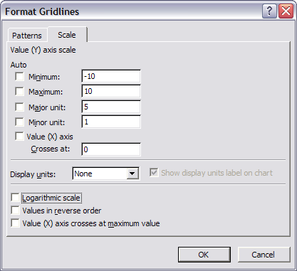
- Repeat step 9 for the y-axis gridlines. Your graph should look like the picture below. Go ahead and test your sheet by entering different values into the slope and intercept boxes. The values in the table should change, and so will the graph.
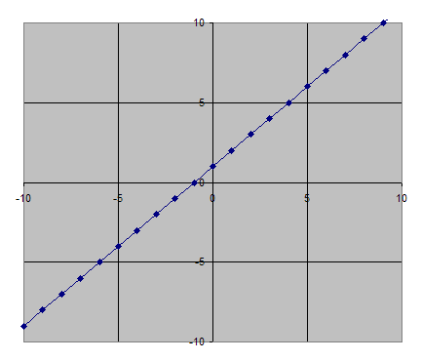

Part 2: Formatting Your Worksheet

Although your worksheet is functional now, it is possible to make it neater and more user-friendly with some more formatting.

1. First, we will make the background of the graph white. Right click anywhere on the background of the graph and choose “Format Plot Area”. (Again, try clicking somewhere else if you don’t see this option). In the “Format Plot Area” window set the “Area” color to be white. Click “OK”. | 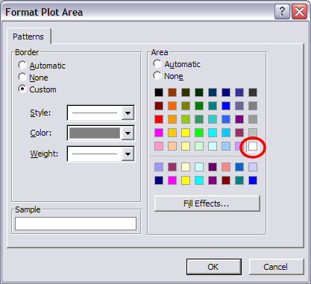
2. Now we will turn the minor gridlines back on. Right click somewhere near the edge of the graph and select “Chart Options”. On the “Gridlines” tab select major and minor gridlines for both x and y axis. Click “OK” | 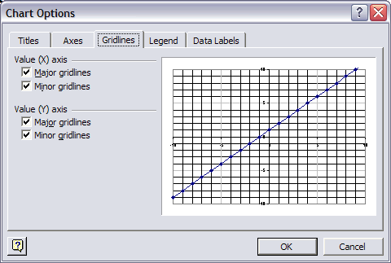
3. Next we will change the gridlines to be gray so that they are not so distracting. To do this, right click on any x-axis gridline and select “Format Gridlines”. In the “Format Gridlines” window select the “Patterns” tab. Then select “custom”, and change the color to a light gray. Click OK.  Repeat this step for the y-axis gridlines. | 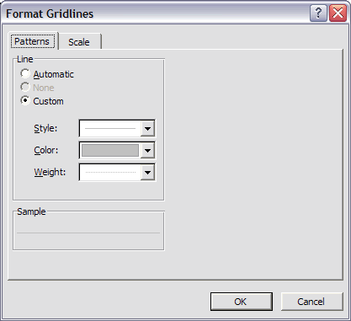
4. Finally, we will make the line thicker and get rid of the individual points. To do this right click anywhere on the line graph and select “Format Data Series”. Select the “Patterns” tab. In the line area on the left select “custom” and set the “weight’ to be the thickest possible. On the “Marker” settings on the right side choose “None”. Click “OK”. | 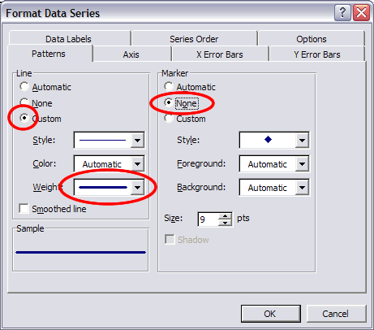
The graph should now look like this:
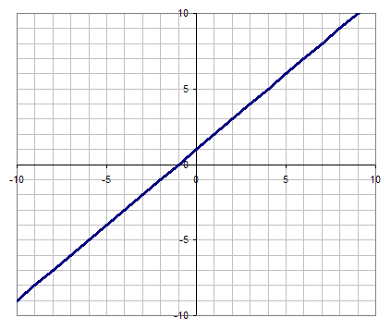

5. Next we will change the background of the slope and intercept cells to be yellow so that they are more prominent. To do this select the slope cell, click on the fill color button , and choose yellow. Do the same thing for the intercept cell.

6. Add the following text just under the title, so that users will have some directions: “*Enter values into the yellow cells to change the slope and intercept of the graph”. In this case I made the text red.

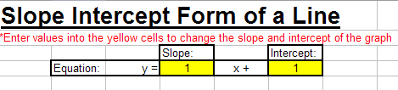

7. Now we will turn the gridlines off from the spreadsheet. To do this, go to the “Tools” menu and select “Options”. In the “View” tab uncheck “gridlines”. This leaves a nice white background on the spreadsheet. | 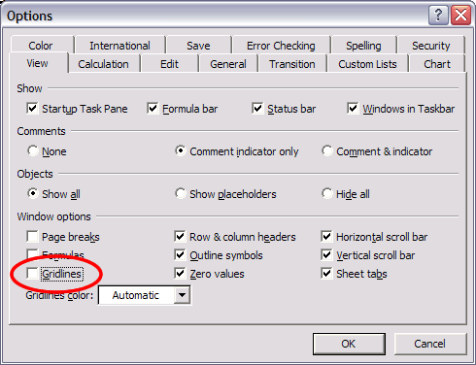
Final spreadsheet appearance:

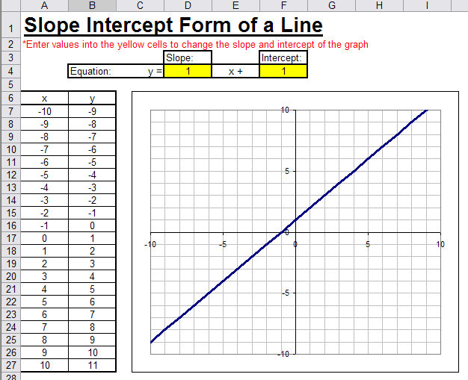

Part 3: Conditional Formatting

In this part of the tutorial we will look at how to use conditional formatting to add interactive questions to spreadsheets.

- Below your table and graph Enter a line of instructions, “Enter your answers into the red boxes. If you are correct, they will turn green”. A few cells below enter the question, “What is the x-intercept of the line y = 3x – 6?”. Add a border around a cell just to the right of the question. This is where the user will type their answer.

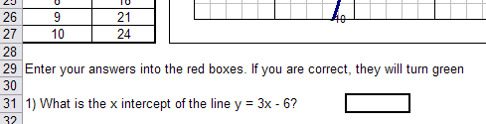

- Select the answer cell. Now go to the “Format” menu and select “Conditional Formatting”. Use the drop down menus to set Condition 1 to “Cell Value Is”, “not equal to”, “2”. And then click on the “Format” button. The formatting we apply will only happen when the cell value is not equal to 2.

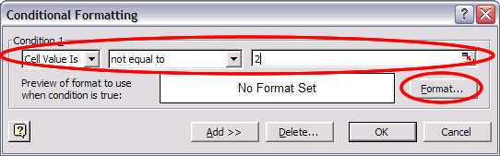

3. In the “Format Cells” window choose the “Patterns” tab. Select red as the color and click “OK”. | 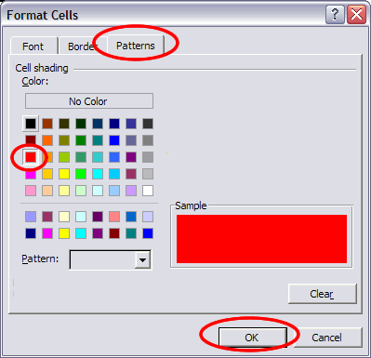

- Back on the “Conditional Formatting” Click “Add >>”. For Condition 2 set, “Cell Value Is”, “equal to”, “2” and then click on “Format”. The formatting we apply will only take place when the cell value is equal to 2.

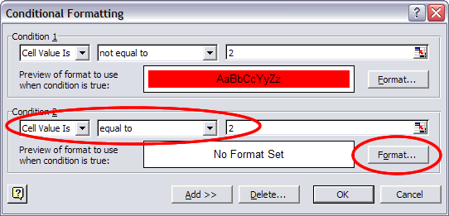

- Repeat step 3, but this time choose the color green.

- Back at the “Conditional Formatting” window click “OK”. Try your cell out by typing numbers in and pressing enter. Any number that is not 2 should result in a red background, while 2 will turn the background green.
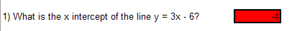
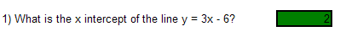

- Now we will look at how you can use the value in one cell to change the formatting of a different cell. Click on the cell just to the right of your answer cell and type, “That’s Correct!”. With this cell selected go the “Format” menu and select “Conditional” formatting.

- This time in “Condition 1” set “Formula Is”. Click in the formula box, then click on the answer cell to select it (the one with the red or green shading). Then type “<>2”. This is < and >, which is used together to mean not equal to. Now this cell will be formatted when the answer cell is not equal to 2. After setting the formula click on “Format”.

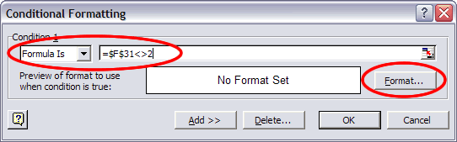

9. This time in the “Format Cells” window click on the “Font” tab. Set the color to white and click “OK”. This will hide the text when the answer is not 2, because the white text on the white background will not be visible. | 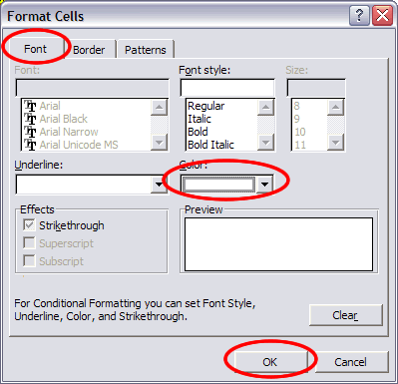
10. Back at the “Conditional Formatting” window click “Add >>”. For Condition 2 select “Formula Is”. Click in the formula box, then click on the answer cell to select it (the one with the red or green shading). Then type “=2”. Now this cell will be formatted when the answer cell is equal to 2. After setting the formula click on “Format”.

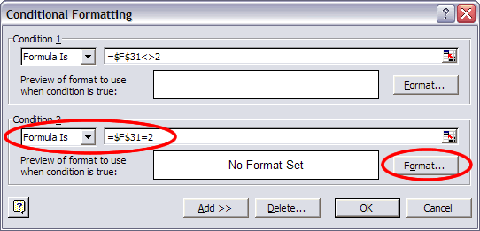

- Repeat step 9, except this time make the text color green. Click “OK” on the “Conditional Formatting” window. Now test your cell by typing in different values for the answers. When it is wrong, there will be no text visible. When it is right, the text will be green.

12. Practice this method by adding another interactive question to the worksheet.

