SWiSHmax Tutorial Part 1:
Setting up a Movie and Drawing Shapes.
By David Young

In this 3-part tutorial we will create a flash movie in SWiSH max in which the user can control the position of an object in the movie by using the mouse or keyboard. This tutorial is intended to be an introduction to SWiSH max and scripting for complete beginners. If you are experienced at all in these areas you may prefer to start at part 2 of the tutorial.

If you are brand new to SWiSHmax and have little or no experience with Flash or graphic design programs I suggest that you browse through the "User Interface" section of the help manual within SWiSHmax. I also recommend all of the tutorials found within the help section. They cover many topics including animations, buttons, multiple scenes, movie control, and much more scripting.
1. Open SWiSHmax and start a new movie (either select "Start a New Empty Movie" when prompted on startup, or select File→New). Save your movie with the "Save As" command. Note: saving your movie creates a .swi file. This is a SWiSHmax specific file format that is your working file. When you are ready to publish your movie you can use the export command to save your movie as a .swf (Shockwave-Flash) movie that will be viewable as a standalone Flash movie or on your webpage.
2. In the panel frame on the right side of the screen select the "movie" tab. For this project I will set the width of the movie to 400 and the Height to 300. I will leave the Frame Rate at the default 15 frames per second and the background as white. | 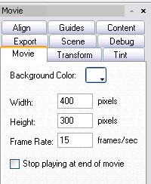
3. From the "Tools" panel just to the left of your movie select the "Ellipse" tool . Click anywhere on your movie canvas and drag to draw your ellipse. If you prefer a circle, hold the shift key while you click and drag to constrain the proportions of the ellipse to be a circle. Your move should now look like the picture below. Notice that the circle now appears in the "Outline" panel on the left under "Scene_1" as "Shape".
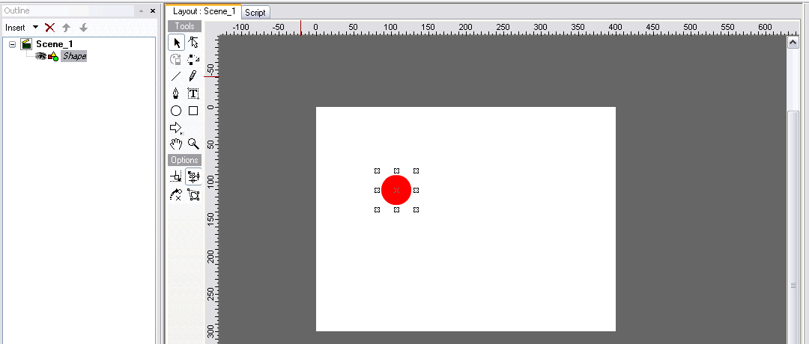
4. You can edit your ellipse by clicking on the "Shape" tab in the control panel on the right. Fill in "dot" for the ellipse's name. Notice that in the outline on the left the ellipse now shows as "dot". Check the "Target" box to the right of the name, this will allow us to refer to the dot in scripts. You can also change the fill properties, colors, and outline of the shape from this panel. I made my dot black with a solid fill. | 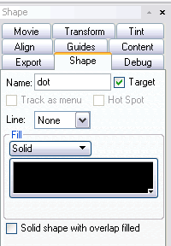
5. Use the "AutoShape" option on the "Tools" panel to draw an arrow on your screen. If you hold your left mouse button down as you are over the "AutoShape" button a submenu will open in which you can select the arrow from several other shapes. After you draw the arrow on your movie, use the "shapes" panel on the right to change the name of the arrow to "right", check the target box, and change the color or fill options to your preference. | 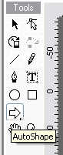
6. Now we will make another arrow pointing to the left. Right click on your arrow on the movie screen and choose "Copy Object". Then right click anywhere on the movie screen and choose "Paste Object". Use the "Shape" panel on the right to change the name of your new arrow to "left". Then click on the "Transform" tab to reveal the transform panel on the right. Your values for X:, Y:, W:, H:, will vary from mine depending on where your arrow is on the screen and what its width and height are. Select the X=Y option to the right of the rotation boxes and then type 180 into the first box. This will rotate your arrow so that it faces left. | 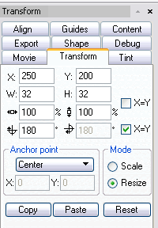
7. You movie and outline should now look like the picture below. You can click any of the shapes on screen to drag them into position or reshape them.
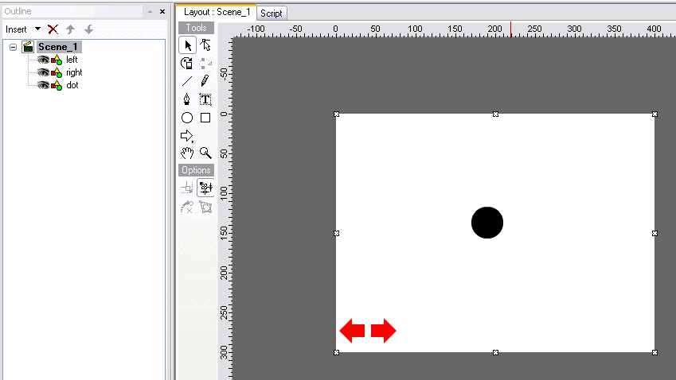

If you can't see all of your movie screen use the controls in the "view" panel under the Tools, to the left of the movie) to change your view. Selecting the "100%" icon will automatically center your movie and resize it to 100%. | 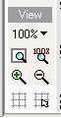
You are now ready for part 2, in which we will use scripting to allow the user to control the position of the dot on the screen with a mouse or keyboard.

