SWiSHmax Tutorial Part 2:
Using Scripts to Control Object Position.
By David Young

This is a continuation of my tutorial part 1, in which we made the objects, named them, and positioned them. To begin this tutorial you will need a movie with three objects: a circle named "dot" an arrow facing to the right named "right" and an arrow facing to the left named "left". Your movie should look like this:
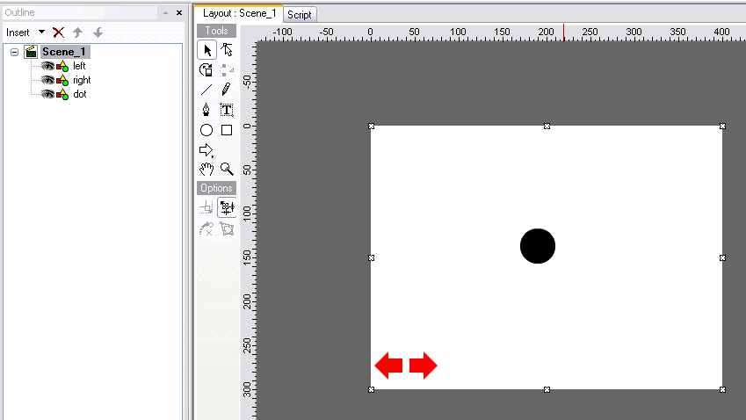
1. So far, we have only worked in the "Layout" view of scene 1. Notice the "Layout" and "Script" tabs above the movie editing area. Clicking the script tab will show the script assigned to whatever object you have selected. Select the "right" arrow and then click on the "Script".
2. In order to add the script we need to define an event for which the event will run. Press the "Add Script" button and then select "Events"→"Button"→"on(press)". Your screen will now look like this:  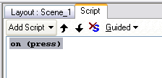 | 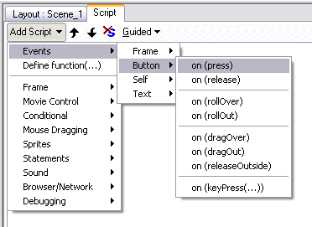
3. Now right click the "on press" text and select: "Add Script"→"Statements"→"name=expr;". This is the code that will set any item equal to something.
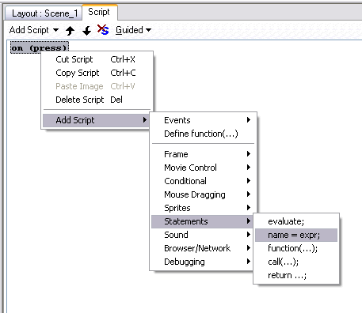
Your screen should now look like this. The code is in red because at the moment it is not complete.
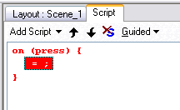
4. With the "=;" statement selected in the script we will use the "=;" panel underneath the script to define this statement. For target select "dot" from the dropdown list. If "dot" does not appear in the list go back to the layout view and check the be sure that your circle is named "dot" and that that target option is selected for it. For "Name" select "_x" from the list. This option will change the x position of the dot on the screen. For the "Operator" select +=(add or plus) and in the box below type 5.
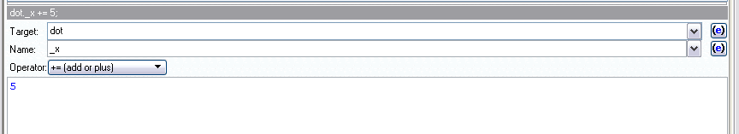
Your script should now look like this:
on (press) {
dot._x += 5;
}
This means that when you press the right arrow the x position of the dot on the screen will increase by 5 pixels.
5. Now test your movie to see if it works. Go back to the layout view and then press the play button on the top toolbar. Click on the right arrow and you should see the dot increment to the right. If you click on it again it will happen again. Press the stop button to stop the movie from playing. Note: In part 3 of this tutorial we will add script to make the dot continue to the right as long as you hold the mouse button down.
6. Repeat steps 1-5 for the left arrow. Everything is the same except in step 4 change the operator to "-=(subtract)". Test your movie again to be sure that both arrows work when you click on them.
7. Now we are going to add the script to move the dot using the left and right arrow keys. In the layout view click on the right arrow or you can click on it in the outline on the left. Then click on the script tab to see the script for the right arrow. Right click on the "on(press) {" line and select "copy script". Now right click on the bottom line of script, in this case "}" and select paste script. Your script should now look like this:
on (press) {
dot._x += 5;
}
on (press) {
dot._x += 5;
}

8. Click on the second "on(press)" command to show the "on(press)" options below. Uncheck the "Press" box and use the "Key:" drop down menu to select "Right"
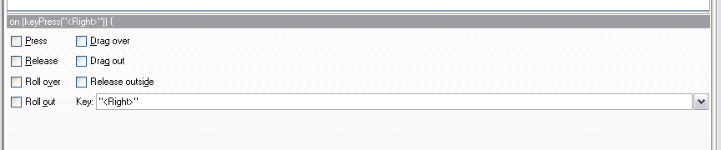
Your code should now look like this:
on (press) {
dot._x += 5;
}
on (keyPress("<Right>")) {
dot._x += 5;
}

9. Repeat steps 7-8 for the left arrow. The only difference is that you will choose the "Left" key in step 8.
10. Test your movie again by clicking "play" while in the "layout" view. Now the dot should move to the left and right when you press (or hold) the left and right keys on your keyboard.
You are now ready for part 3 of this tutorial in which we will use conditional statements and variables to make the dot continue to move while you hold your mouse key down on either arrow.

