SWiSHmax Tutorial Part 3:
Conditional Statements and Variables in Scripts.
By David Young

This is a continuation of my tutorial parts 1 and 2 . In part 1 we made the objects, named them, and positioned them. In part 2 we used scripts to allow the user to control an object's position on screen with the keyboard or by clicking a button on the movie. To begin this tutorial you will need a movie with three objects: a circle named "dot" an arrow facing to the right named "right" and an arrow facing to the left named "left". Your movie should look like the picture below:
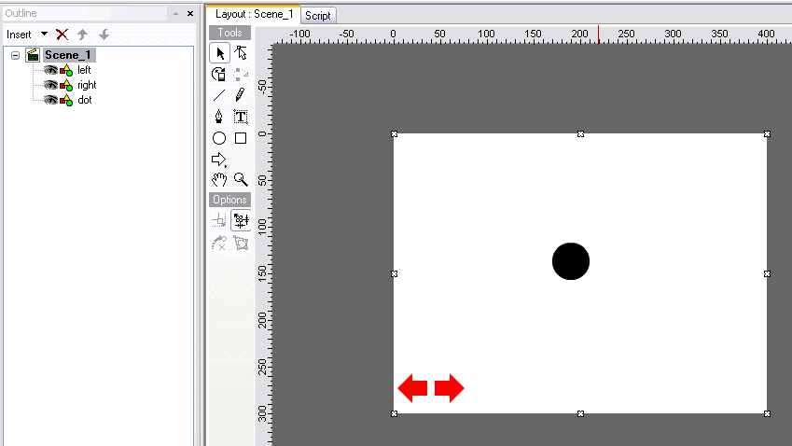
The "left" arrow should contain the script: |  | The "right" arrow should contain the script:
on (press) {  dot._x -= 5;  }  on (keyPress("<Left>")) {  dot._x -= 5;  } |  | on (press) {  dot._x += 5;  }  on (keyPress("<Right>")) {  dot._x += 5;  }
Currently when you click on an arrow the dot increments only once for each click. We will add the feature that the dot will continue to move as long as you hold the mouse down. To do this we will define variables that will determine if the mouse is being held down or not.
- Select "Scene_1" by clicking on any blank area on the movie screen or by selecting it in the outline. Then click on the "Script" tab to show the script for Scene 1, it should currently be blank. We are going to add the following script to Scene 1:

onLoad () {
rightpress = 0;
leftpress = 0;
}

There are several ways you can add this script to scent 1. You can Select "Add Script"→"Events"→"Frame"→"onLoad()" to get the onLoad event. Now highlight the "onLoad()" command in the script, right click and select "AddScript"→"Statements"→"name=expr;". In the menu below set the "Name" to "rightpress", the "Operator" to "= (set value)" and the value below to 0. This is seen in the picture below. You can add the statement for the leftpress variable in the same way, or by copying and pasting the rightpress statement and changing the name to leftpress.
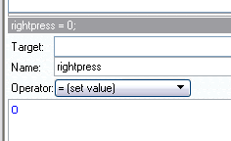

Note: You can also copy and paste the script directly from this word document. To do this you must change the scripting option from "Guided" to "Expert". This tab is right under the "Script" tab. After doing so, you will want to change back to the "Guided" mode.

Analysis: This code will be executed when the scene is loaded. It establishes that at the time of loading the buttons are not being pressed.
- Now we will add script to the right and left arrows so that when they are clicked the variables will store a value of 1. Use the method described above to add the statement "leftpress=1" to the left arrow and "rightpress=1" to the "onPress()" commands of each arrow. Your script for the arrows should now look like this:

Left Arrow:  on (press) {  leftpress = 1  dot._x -= 5;  }  on (keyPress("<Left>")) {  dot._x -= 5;  } | Right Arrow:  on (press) {  rightpress = 1  dot._x += 5;  }  on (keyPress("<Right>")) {  dot._x += 5;  }
3. Now we will add script to the arrows so that when we release the mouse button the value of the leftpress or rightpress will go back to zero. To do so, view the code for the right arrow, and select "Add Script"→"Events"→"Button"→"on(release)". Select the "on(release)" command and check the "Release Outside" box in the menu below. Add the following script to this event: "rightpress = 0". Do the same thing for the left arrow. Your script for each arrow will not look like this:
Left Arrow:  on (press) {  leftpress = 1  dot._x -= 5;  }  on (keyPress("<Left>")) {  dot._x -= 5;  }  on (release,releaseOutside) {  leftpress = 0;  } | Right Arrow:  on (press) {  rightpress = 1  dot._x += 5;  }  on (keyPress("<Right>")) {  dot._x += 5;  }  on (release,releaseOutside) {  rightpress = 0;  }
Analysis: When the scene is loaded the variables leftpress and rightpress are set to zero. If you click on an arrow the variables become equal to 1. When you release the mouse button, whether your mouse is still on the arrow or not, the values go back to zero.
4. To complete our task we will now add script to the scene that will increment the dot whenever leftpress or rightpress is equal to 1. Select "Scene_1" and view its script. Add code for the event "onEnterFrame()". You can add this by selecting "Add Script"→"Events"→"Frame"→"onEnterFrame()". This event happens on every frame, in our case this is 15 times per second. Now your script for "Scene_1" should look like this:

onLoad () {
rightpress = 0;
leftpress = 0;
}
onEnterFrame() {
}
5. Right click the "onEnterFrame()" line of code and select selecting "Add Script"→"Conditional"→"If(...){". Your screen should look like the picture to the right. The "onEnterFrame()" and "if()" statements are in red because they are not complete. With the "if(){" line highlighted enter the statement "rightpress==1" into the box below. Note that you must use 2 = signs. In the script, = is a statement of assignment, where == is a statement of comparison. | 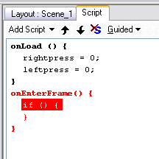
Now your code for "Scene_1" should look like this:  onLoad () {  rightpress = 0;  leftpress = 0;  }  onEnterFrame() {  if (rightpress==1) {  }  } | 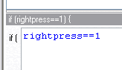
6. Highlight the "if (rightpress==1){" line of code and enter the code "dot._x += 5". You can do this by selecting "Add Script"→"Statements"→"name=expr;". For target select "dot" from the dropdown list. For "Name" select "_x" from the list. For the "Operator" select +=(add or plus) and in the box below type 5. Or, you can simply copy and past this line of code from the left arrow.

Your code for "Scene_1" should now look like this:
onLoad () {
rightpress = 0;
leftpress = 0;
}
onEnterFrame() {
if (rightpress==1) {
dot._x += 5;
}
}
Analysis: On each frame the scene will check to see if rightpress is equal to 1. If it is, then it will move the dot 5 pixels to the right.
7. Now we have to add the same command for leftpress. The quickest way to do this is to copy the code and make changes. Right click the "if(rightpress==1)" line of code and select "Copy Script. Highlight the "}" that comes at the end of the "if" command (not the one at the end of the "onEnterFrame" command), right click, and select "Paste Script". Highlight a line to change it. Change the if line to leftpress==1 and change the increment on the dot from "+=" to "-=". Your code for "Scene_1" should now look like this:

onLoad () {
rightpress = 0;
leftpress = 0;
}
onEnterFrame() {
if (rightpress==1) {
dot._x += 5;
}
if (leftpress==1) {
dot._x -= 5;
}
}
8. Test your movie to be sure it works. If you press an arrow and hold the mouse button down the dot should continue to move until you release the button. The keyboard should also continue to move just like before. In addition to the pressing the play button in layout view you can also test the movie in a player or in a browser by selecting "Test" under the "File" menu.
9. Now we will export the movie as a flash movie, .swf. Select "File"→"Export", then you can choose to export just the .swf movie file or the .swf movie plus a .html file which has the movie embedded in it. Choose whichever you prefer and then try opening the file from your hard drive to make sure it works. You will, of course, have to have a Flash player installed, but this is standard on newer versions of all browsers.
Final Thoughts: With this tutorial you have received an introduction to several features of SWiSHmax that I hope will open the door for further exploration. A good way to solidify the skills you just learned would be to go back and add up and down controls to your movie. Please email me if you have any comments or suggestions for this tutorial: youngdj@ufl.edu.

